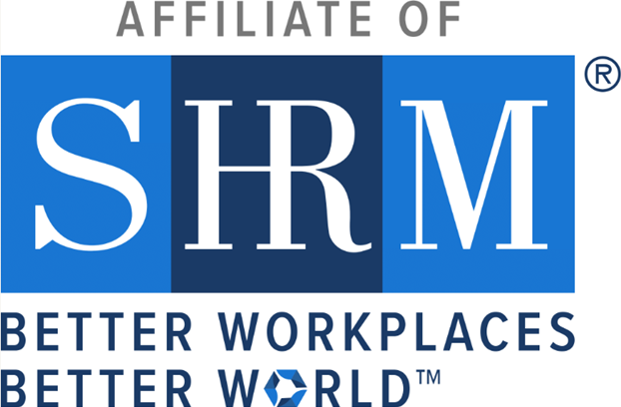
Insert Your Chapter/State Council Logo Here

[STATE COUNCIL/CHAPTER NAME] Awarded
For Elevating Human Resources, Improving Workplaces

[CITY, STATE (e.g., ALEXANDRIA, Va.)], April XX, 2024 — SHRM recently awarded [STATE COUNCIL/CHAPTER NAME] its prestigious EXCEL [TYPE OF EXCEL Award (i.e., Bronze, Silver, Gold and Platinum)] Award for the [CHAPTER’s or COUNCIL’s] accomplishments in 2023.

The EXCEL award is given to state councils and chapters to recognize major accomplishments, strategic activities, and tactical initiatives that elevate the profession of human resources.

“SHRM’s impact on the world of work is due to the dedication and efforts of our chapters and state councils like [STATE COUNCIL or CHAPTER NAME]. “The [TYPE] EXCEL Award is not only a celebration of the great work done by [CHAPTER/COUNCIL]—it’s also recognition of their focus and determination to cause the effect to make great workplaces”, said Johnny C. Taylor, Jr., SHRM-SCP, president, and chief executive officer of SHRM. “Their HR leadership is exemplary.”
The EXCEL Award can be earned at four levels: bronze, silver, gold and platinum. Each level has a prescribed set of requirements and accomplishments that must be met. [STATE COUNCIL/CHAPTER NAME] will receive recognition in SHRM publications and at conferences, a logo to display on its website, and information to share with its members about the significance of this award.

[INSERT SHORT, 3- TO 4-SENTENCE PARAGRAPH ABOUT CHAPTER/COUNCIL ACCOMPLISHMENTS.]

For more information about [INSERT CHAPTER/COUNCIL NAME], visit [INSERT WEBSITE ADDRESS].

Media: For more information, contact Edward Burke, at Edward.Burke@shrm.org or 703-535-6036.

[INSERT CHAPTER/COUNCIL BOILERPLATE]

About SHRM

SHRM is a member-driven catalyst for creating better workplaces where people and businesses thrive together. As the trusted authority on all things work, SHRM is the foremost expert, researcher, advocate, and thought leader on issues and innovations impacting today’s evolving workplaces. With nearly 340,000 members in 180 countries, SHRM touches the lives of more than 362 million workers and their families globally. Discover more at SHRM.org.

