Press Release Template

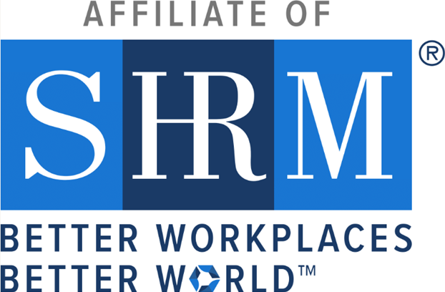
Insert Your Chapter/State Council Logo Here

[STATE COUNCIL/CHAPTER NAME] Honored for Elevating HR and Enhancing Workplaces
Receives SHRM’s Prestigious 2024 [Award Level] Excel Award

[CITY, STATE] — May XX, 2024 — SHRM has awarded the 2024 [Award Level] Excel Award to [STATE COUNCIL/CHAPTER NAME] in recognition of its exceptional work and accomplishments in 2024. This award celebrates the Chapter’s/State Council’s strategic initiatives, innovative programming, and unwavering commitment to elevating the HR profession and improving workplaces across the region.

The Excel Award—given at the Bronze, Silver, Gold, and Platinum levels—is a symbol of excellence in chapter and state council leadership. Honorees are recognized for activities that align with SHRM’s mission to empower people and workplaces by advancing human resource practices and maximizing human potential.

“SHRM’s impact on the world of work is made possible by the dedication and leadership of our chapters and state councils,” said Johnny C. Taylor, Jr., SHRM-SCP, president and chief executive officer of SHRM. “The [Award Level] Excel Award is not only a celebration of the great work done by [CHAPTER/COUNCIL NAME]—it’s recognition of their focus, innovation, and determination to create better workplaces. Their HR leadership is truly exemplary.”

[STATE COUNCIL/CHAPTER NAME] will receive national recognition through SHRM publications and events, an official award logo for use in communications, and tools to help share this achievement with its members and community.

In 2024, the [Chapter/Council Name] led several impactful initiatives, including [INSERT A FEW KEY ACCOMPLISHMENTS OR PROGRAM HIGHLIGHTS], supporting the growth and success of HR professionals and organizations across [State/Region].

For more information about [STATE COUNCIL/CHAPTER NAME], visit [INSERT WEBSITE].

General Social Media Template

🎉 We’re honored to receive the 2024 [Award Level] Excel Award!

This recognition from @SHRM celebrates our commitment to advancing the HR profession and creating better workplaces across [State/Region].

Thank you to our incredible board and volunteers for making this possible! 💼💙

#SHRMExcelAward #HRLeadership #BetterWorkplaces #SHRM [#YourChapterHashtag]

LinkedIn Post Template

We’re proud to share that [Chapter/State Council Name] has been awarded the 2024 SHRM [Award Level] Excel Award by @SHRM!

This national recognition reflects the hard work and dedication of our board and volunteers in advancing the HR profession and supporting our local HR community.

Thank you to everyone who made this achievement possible—this is your award too!

#SHRMExcelAward #HRLeadership #BetterWorkplaces #SHRM #HRCommunity #YourChapterHashtag

Instagram Story Template

(Consider pairing this with a graphic of the Excel Award logo!)

Slide 1:
🎉 We’re an award-winning SHRM chapter!

Slide 2:
Proud to receive the 2024 [Award Level] Excel Award from @shrmofficial 🏆

Slide 3:
Thanks to our board, members & volunteers for making this happen! 💼💙

#SHRMExcelAward #CauseTheEffect #HRLeadership

