THANK YOU!

As 2022 comes to an end, it’s a time for all of us to express our gratitude and we could not be more appreciative of the support you provide to SHRM Foundation. It’s also time to reflect on all the progress we are making in our shared vision of building better workplaces and a better world. Your donations have helped the SHRM Foundation address the health, economic and social disruptions impacting work, workers, and the workplace.

We know that you are making a choice with your volunteer time and our goal is to provide all the support you need to run an end of year giving campaign on behalf of the SHRM Foundation. Because we know you are busy, we have done most of the work for you. This “End of Year Giving Toolkit” contains an email template and social media posts you can share to encourage end of year giving. We have included a special set of messaging for GivingTuesday, which is held every year on the Tuesday after Thanksgiving and will take place this year on November 29.

If you have an active social media presence please adapt, localize, make your own. Consider sharing why you support SHRM Foundation with your time, talent and treasure and inspire others in your network to do the same.

Our programs and resources have never been more critical. Your support in 2023 will continue to fuel SHRM Foundation programs in the following areas: workplace mental health and wellness; reskilling and upskilling resources; strategies for building inclusive workplaces; and mentorship and scholarship opportunities designed to inspire and empower emerging HR professionals.

Thank you for your generosity and ongoing support of the SHRM Foundation. Together, we are mobilizing the power of HR and the generosity of donors to lead positive social change.

For additional questions or support, please contact Beth Conti at Beth.Conti@shrm.org.

With Gratitude,

The SHRM Foundation

EMAIL TEMPLATE: Giving Tuesday, Nov 29

Toolkit graphics can be found HERE
File name: 2022 EOY Giving Tuesday Graphic 1200x628.png

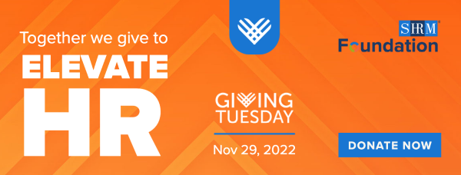

Dear [INSERT NAME],

Thanksgiving and Giving Tuesday is a time for all of us to express our gratitude and we could not be more appreciative of the support you provide to the SHRM Foundation.

What is GivingTuesday?
GivingTuesday is a global generosity movement that unleashes the power of radical generosity around the world. GivingTuesday was created in 2012 as a simple idea: a day that encourages people to do good. Over the past ten years, this idea has grown into a global movement that inspires hundreds of millions of people to give, collaborate, and celebrate generosity.

Together we give to elevate HR. Positive change in the workplace starts with you and your support of the work of SHRM Foundation. On Giving Tuesday, we are asking you to become part of Team Empower by donating at least $30.00 to set SHRM Foundation up for even more success in 2023.
DONATE NOW

SHRM Foundation is committed to addressing the health, economic and social disruptions impacting work, workers, and the workplace. Their programs and resources have never been more critical. HR professionals have an indispensable role in accelerating the recovery of work and workers by providing innovative and timely evidence-based solutions and resources for employers and employees across the globe. Support for these resources is urgent and only made possible by the generosity of individuals like you. Learn more at shrmfoundation.org.

Please also take a moment when donating to provide recognition credit to our chapter and state council.

With Gratitude,

[INSERT YOUR NAME]

EMAIL TEMPLATE: General Giving

Toolkit graphics can be found HERE
File name: 2022 EOY Giving Email Banner 600x228.png

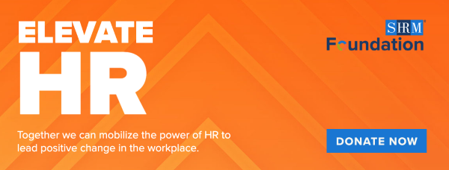

Dear [INSERT NAME],

Everyone has a role to play in creating a world of work that works for all. The power of HR to be a social force to lead positive change in the workplace starts with you and your support of the work of SHRM Foundation. On Giving Tuesday, we are asking you to become part of Team Empower by donating at least $30.00 to set SHRM Foundation up for even more success in 2023.
DONATE NOW

SHRM Foundation is committed to addressing the health, economic and social disruptions impacting work, workers, and the workplace. Their programs and resources have never been more critical. HR professionals have an indispensable role in accelerating the recovery of work and workers by providing innovative and timely evidence-based solutions and resources for employers and employees across the globe. Support for these resources is urgent and only made possible by the generosity of individuals like you. Learn more at shrmfoundation.org.

Please also take a moment when donating to provide recognition credit to our chapter and state council.

With Gratitude,

[INSERT YOUR NAME]

SOCIAL MEDIA POSTS: Nov 29, Giving Tuesday Support for SHRM Foundation

We’ve developed a suite of social media post for you to announce and show your support for SHRM Foundation on Giving Tuesday. If you have an active social media presence please adapt, localize, make your own. Consider sharing why you support SHRM Foundation with your time, talent and treasure and inspire others in your network to do the same.

Starting on Monday, November 28 and Tuesday, November 29 (#GivingTuesday), please share out the posts below on one or all your social channels. All accompanying social graphics can be found HERE.

Please note that SHRM Foundation social media accounts are no longer active as of April 2022. We are now directing all followers and posting content directly on SHRM official accounts. Should you want to follow or tag us please use these tags to your posts below with the hashtag #SHRMFoundation.

- LinkedIn: @SHRM
- Facebook: @SHRMHQ
- Twitter: @SHRM
- Instagram: @SHRMOfficial

About Giving Tuesday
Giving Tuesday is a global generosity movement that unleashes the power of radical generosity around the world. Giving Tuesday was created in 2012 as a simple idea: a day that encourages people to do good. Over the past ten years, this idea has grown into a global movement that inspires hundreds of millions of people to give, collaborate, and celebrate generosity.

LinkedIn / Facebook
Text & Link | Image: 2022 EOY Giving Tuesday Graphic 1200x628.png
This #GivingTuesday, the power of #HR to be a social force to lead positive change in the workplace starts with you and your support of #SHRMFoundation.  Your generosity will directly support innovative programs and initiatives that address some of the most critical workplace issues: workplace #mentalhealth and wellness; recruiting and retaining untapped and underrepresented talent; and creating new training resources and opportunities for employees and emerging professionals in our changed world.  Donate today: https://shrmfoundation.org/ | 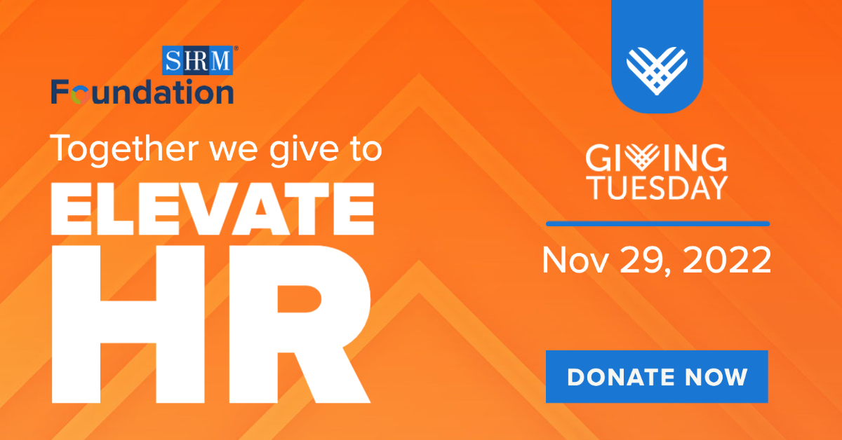

Twitter
Text & Link | Image: 2022 EOY Giving Tuesday Graphic 1200x628.png
On #GivingTuesday, the power of #HR to be a social force to lead positive change in the workplace starts with you & your support of #SHRMFoundation. Your generosity will fund innovative programs & initiatives that address critical workplace issues. Donate: https://shrmfoundation.org/

Instagram
Text & Link | Image: 2022 EOY Giving Tuesday Graphic 1200x1200.png
This #GivingTuesday, the power of #HR to be a social force to lead positive change in the workplace starts with you and your support of #SHRMFoundation.  Your generosity will directly support innovative programs and initiatives that address some of the most critical workplace issues: workplace inclusion challenges, programming and scholarships designed to inspire and empower the next generation of HR leaders, reskilling and upskilling workers for todays and tomorrow’s challenges and inculcating transformational change in support of workplace mental health and wellness.  See link in bio to donate today: https://shrmfoundation.org/  Posting Note: Links in Instagram captions don’t link out, so add link above to your bio to allow users to donate. | 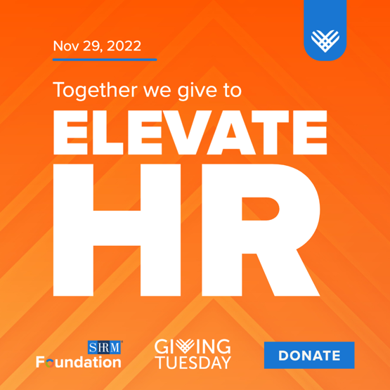

Story (Facebook or Instagram)
Text & Link | Image: 2022 EOY Giving Tuesday Story Graphic 1080x1920.png
Posting Note: Be sure to add the link to donate on the story: https://shrmfoundation.org/  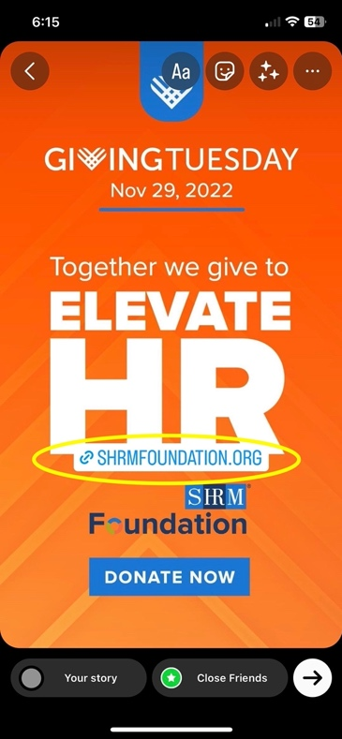 | 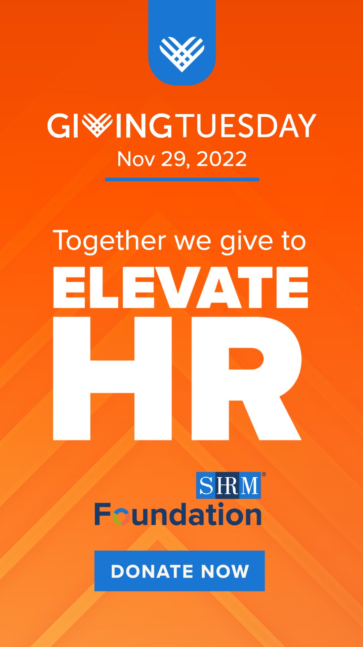

Giving Story – LinkedIn / Facebook
Text & Link | Image: 2022 EOY Giving Tuesday I'm Supporting Graphic 1200x628.png
Posting Note: Share your giving story here and why you support SHRM Foundation with your time, talent and treasure and inspire others in your network to do the same. If you know someone who has a giving story you can also nominate them to share by tagging them.  This #GivingTuesday I’m supporting #SHRMFoundation because [THE REASON YOU CHOOSE TO GIVE].  Please join me in elevating HR and building a world of work that works for all. Donate today: https://shrmfoundation.org/  #MyGivingStory | 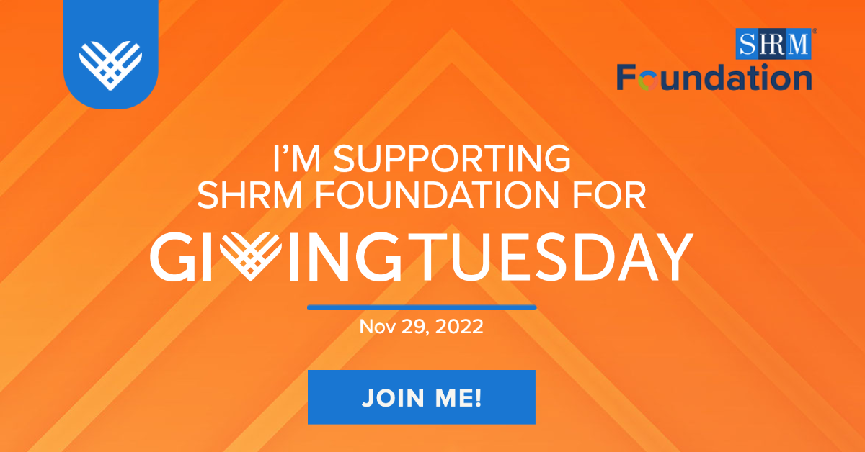

How to Support Us – LinkedIn / Facebook / Instagram
Text & Link | Image: 2022 EOY Giving Tuesday Checklist Graphic 1200x1200.png
There are many ways you can join me in supporting #SHRMFoundation this #GivingTuesday. From simply resharing this post to donating you can support innovative programs and initiatives that address some of the most critical workplace issues: workplace inclusion challenges, inculcating transformational change in support of workplace mental health and wellness, reskilling and upskilling workers for todays and tomorrow’s challenges and programming and scholarships designed to inspire and empower the next generation of HR leaders.  Everyone has a role to play in creating a world of work that works for all. Learn more: https://shrmfoundation.org/  Posting Note: Links in Instagram captions don’t link out, so please add the text “See link in bio” and cut and paste link below in your bio: https://shrmfoundation.org/ | 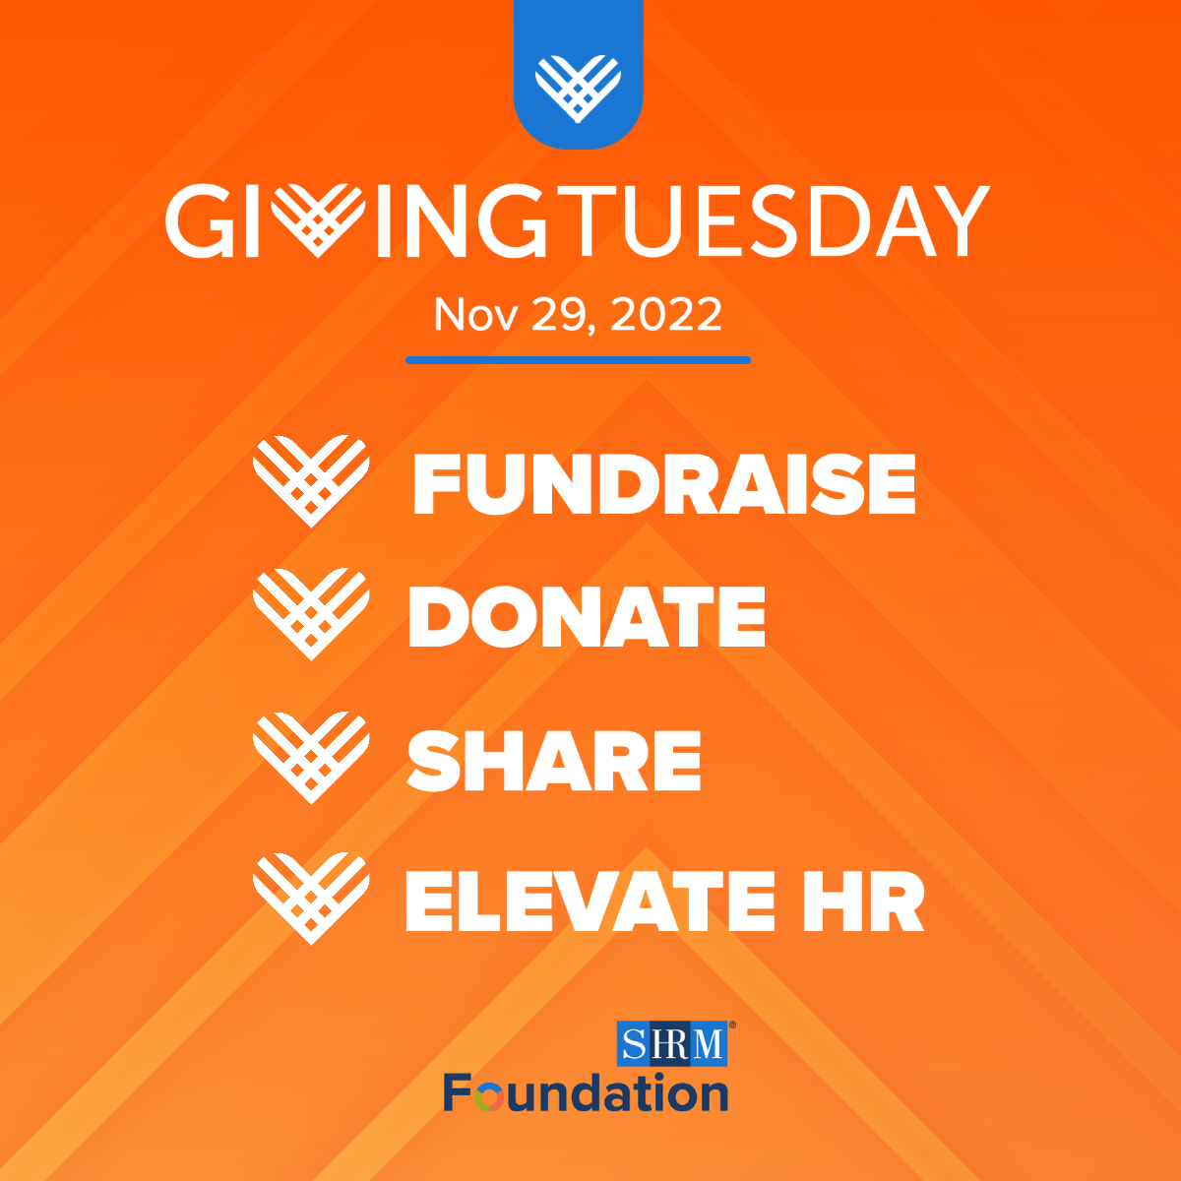

Additional Post – LinkedIn / Facebook
Text & Link | Image: 2022 EOY Giving Social Flyer.png
This #GivingTuesday, your generosity will directly support #SHRMFoundation’s innovative programs and initiatives that address some of the most critical workplace issues: Your generosity will directly support innovative programs and initiatives that address some of the most critical workplace issues: workplace inclusion challenges, inculcating transformational change in support of workplace mental health and wellness, reskilling and upskilling workers for todays and tomorrow’s challenges and programming and scholarships designed to inspire and empower the next generation of HR leaders.  Please join me in elevating HR and building a world of work that works for all. Donate today: https://shrmfoundation.org/ | 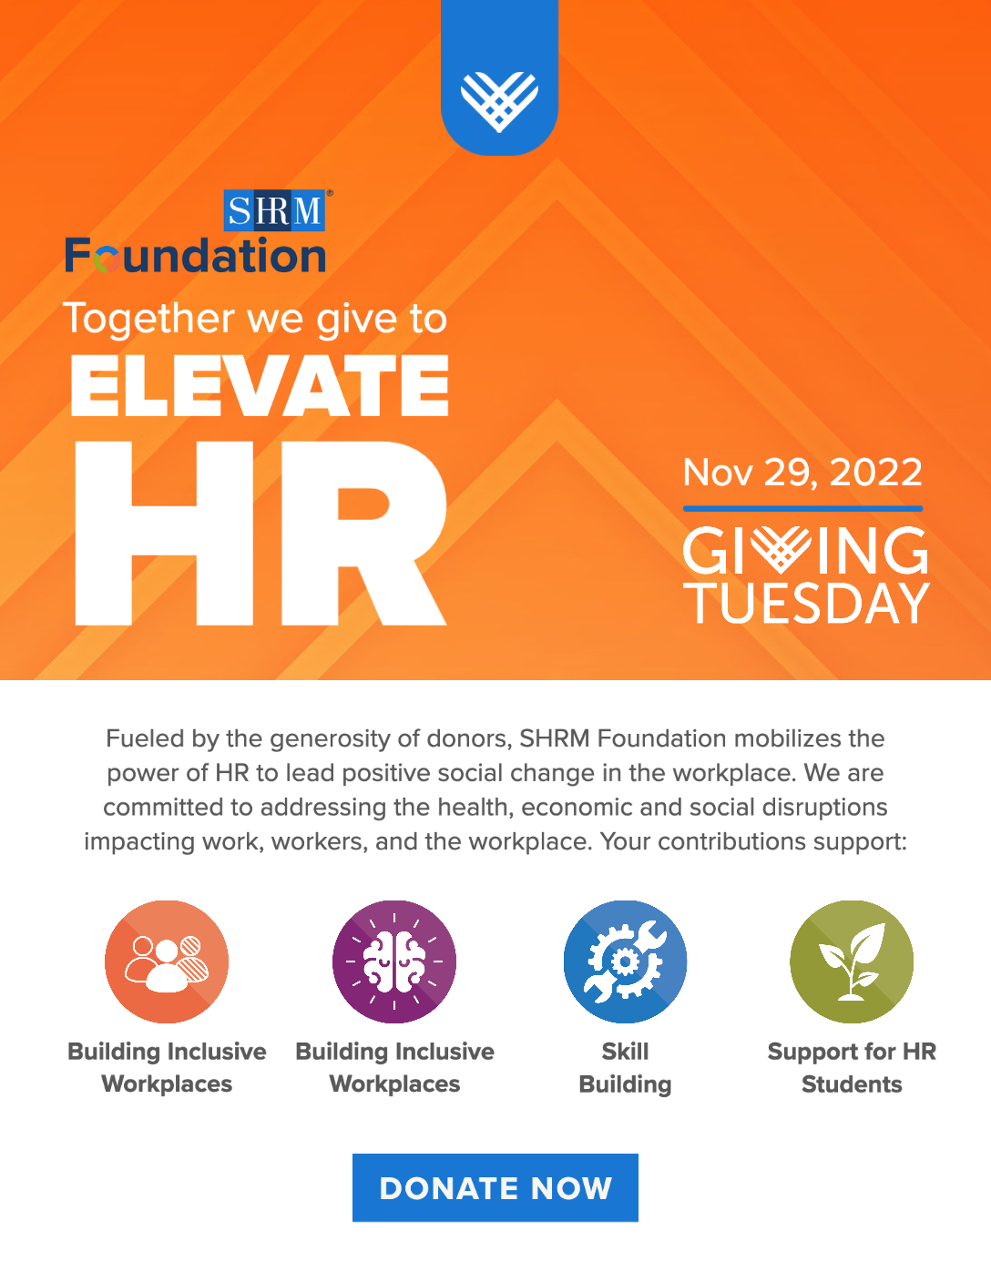

SOCIAL MEDIA POSTS: General End of Year Support for SHRM Foundation

We’ve developed a suite social media messaging for you to announce and show your support for SHRM Foundation. Please share out the posts below on one or all your social channels. All accompanying social graphics can be found HERE.

Please note that SHRM Foundation social media accounts are no longer active as of April 2022. We are now directing all followers and posting content directly on SHRM official accounts. Should you want to follow or tag us please use these tags to your posts below with the hashtag #SHRMFoundation.

- LinkedIn: @SHRM
- Facebook: @SHRMHQ
- Twitter: @SHRM
- Instagram: @SHRMOfficial

LinkedIn / Facebook
Text & Link | Image: 2022 EOY Giving Graphic 1200x628.png
The power to elevate #HR to build better workplaces and a better world starts with you and your support of #SHRMFoundation. Join me in donating to SHRM Foundation to support mission driven programs for workplace inclusion challenges, programming and scholarships designed to inspire and empower the next generation of HR leaders, reskilling and upskilling workers for todays and tomorrow’s challenges and inculcating transformational change in support of workplace mental health and wellness.  Together, we are mobilizing the power of HR to lead positive social change.  Donate today: https://shrmfoundation.org/ | 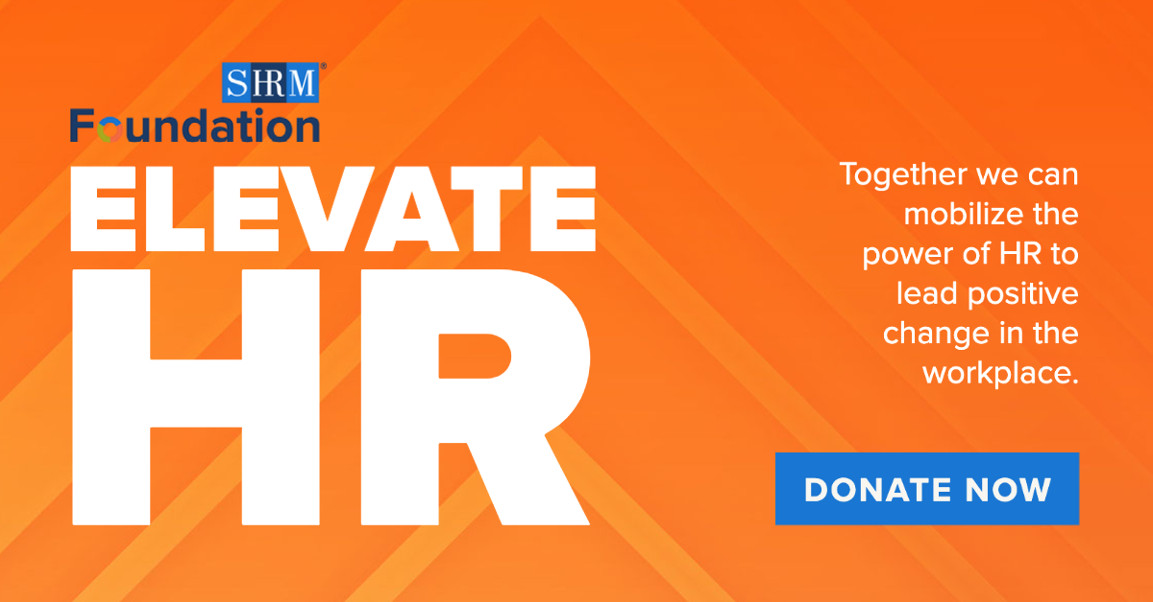

Twitter
Text & Link | Image: 2022 EOY Giving Graphic 1200x628.png
The power of #HR to be a social force to lead positive change in the workplace starts with you and your support. Join me in donating to #SHRMFoundation to support mission-driven programs that create a world of work that works for all. Donate: https://shrmfoundation.org/

Instagram
Text & Link | Image: 2022 EOY Giving Graphic 1200x1200.png
The power to elevate #HR to build better workplaces and a better world starts with you and your support of #SHRMFoundation. Join me in donating to SHRM Foundation to support mission driven programs for workplace inclusion challenges, programming and scholarships designed to inspire and empower the next generation of HR leaders, reskilling and upskilling workers for todays and tomorrow’s challenges and inculcating transformational change in support of workplace mental health and wellness.  Together, we are mobilizing the power of HR to lead positive social change.  See link in bio to donate today: https://shrmfoundation.org/  Posting Note: Links in Instagram captions don’t link out, so add link above to your bio to allow users to donate | 